Example completed recording sheet.
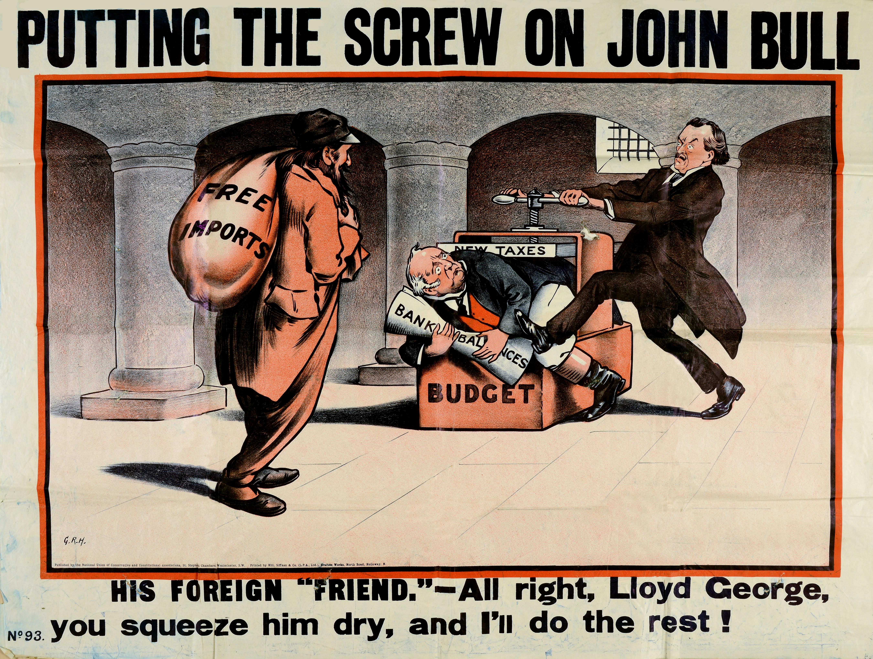

Cartoon entitled: Putting the screw on John Bull, 1909, Catalogue ref: COPY 1/345 f.115.

Cartoon analysis recording sheet.

Title of cartoon and caption (if any): Cartoon called: Putting the screw on John Bull, G.R. Halkett 1909, Catalogue ref: COPY 1/345 f115.
Caption: ‘His foreign ‘friend’- All right, Lloyd George, you squeeze him dry, and I’ll do the rest’.
What can you see?
In a basement, possibly under Parliament, with a small-barred window, a man [John Bull] is forced into a box called ‘Budget’ and held in place by a mechanical device called ‘New Taxes’. A man [Lloyd George] turns a handle to apply pressure rather like a printing press. A large third man with a sack called ‘Free Imports’ looks on.
Name of artist (if known) | George Roland Halkett (G.R.H.)
Background on artist | Editor of ‘Pall Mall Magazine’ and ‘Punch’ cartoonist
Source for cartoon | Published by the National Union of Conservative and Constitutional Associations [Conservative Party]
Historical context | The Liberal Party came to power after a landslide election in 1906 committed to tackling the issue of poverty. Lloyd George, Chancellor of the Exchequer was responsible for the ‘Peoples’ Budget’ to pay for their social reforms, including old age pensions. According to this budget, money would be raised by higher taxes which would have affected the upper classes. The cartoon also highlights other issues apart from welfare and the taxation to pay for it. It also refers to Lloyd George’s support for a policy of free trade, he is the ‘friend’ of foreign traders. The Conservatives felt that helping foreign traders outside the Empire to sell in Britain was not fair to home manufacturers.  The budget was rejected by the House of Lords which led to an immediate general election. It was passed in April 1910. In 1911 an act was passed which said that the House of Lords could no longer reject money bills or delay other public bills. The length of a Parliament was also reduced from seven to five years.  The budget increased income tax and death duties and introduced a new supertax at sixpence in the pound paid on incomes over £5,000 a year (more than £350,000 today.) It also raised taxes on luxury goods like tobacco, whisky, and petrol. There was a new land tax for landowners and heavy taxation on profit made if property was sold. Finally, the budget did not introduce taxation for imported goods as this would have hit the poor hardest.
List the objects or people you can see in the cartoon | Sack & press machine, scroll, Lloyd George, John Bull and foreign trader.
Find any or words/phrases used to identify people or objects in the cartoon | ‘Budget’ and ‘New taxes’ are used to label parts of the press to suggest that the budget was a way of literally squeezing the ordinary man ‘John Bull.’ He holds a scroll which says ‘Bank Balances’ which refers to John Bull’s own money as being reduced by the Budget through ‘New Taxes’, the ‘label’ used for the press. ‘Free imports’ is the name of the sack belonging to the third man in the cartoon. This is a reference to the fact that the budget did not place export duties on goods coming into the country and it links to the caption ‘His foreign friend’. Lack of duties for those sending goods coming into the country suggests that ‘foreign friends can ruin trade for British manufacturers. This is called a policy of free trade which the opposition Conservatives did not support. They favoured of protection within the Empire and were against free trade outside of it.
Find any dates/numbers used to identify people or objects in the cartoon | There are dates or numbers in the cartoon, but we know that the source was copyrighted in 1909.
What can you infer?
Are any of the objects/people listed symbols? | Yes, the press symbolizes the budget and John Bull represents the British people.
Can you explain what the symbols mean? | John Bull is an imaginary figure frequently appearing in political cartoons from the 18th century. He was used in cartoons to represent the nation of Britain, an honest man, free and loyal to his country. Bull is shown as the victim of this heavy-handed budget represented by the press operated by Lloyd George. The size of the figures is also significant in the interpretation of this cartoon- Lloyd George and the import trader man are larger than the smaller John Bull which makes them look like the key villains in the scene. The location too of the underground basement is possibly under the Houses of Parliament is suggestive of the gunpowder plot. The budget viewed by conservatives a plan to destroy the upper classes.
Which words/phrases in the cartoon seem the most important? Can you say why? | ‘New taxes’ are being attacked and show as unfair in the cartoon as well as the Liberal policy on free trade considered to be threaten British manufacturers at home if foreign exporters could sell their products in Britain without paying duties. The Conservatives wanted a policy of protection in trade.
What key words would describe the emotions expressed in the cartoon? | Menace, torture of the ordinary British man, trickery, unfairness.
What can we conclude?
Describe the scene/actions taking place in the cartoon | In an underground basement, with a barred window, a man [John Bull] is forced into a box called ‘Budget’ and held in place by a mechanical device called ‘New Taxes’. A man [Lloyd George] turns a handle to apply pressure rather like a printing press. A large third man with a sack called ‘Free Imports’ looks on.
How do the words help explain the symbols used in the cartoon | The words are helpful because they signal why the man is being ‘punished’.
Explain the message behind the cartoon | The message is anti-budget and Lloyd George for trying to squeeze the upper classes with new taxes and lack of protection in trade. The taxes on goods like tobacco, whisky and petrol would probably have affected the rich more than the whole nation. The cartoonist’s use of John Bull to symbolize the British people therefore was not accurate, not everyone would not have to pay ‘super tax’ as there was such a gap between rich and poor. John Bull’s presence in suggests the cartoonist’s distaste for the budget and the Liberal party.
Which audience(s) would agree or disagree with cartoon’s message? Explain why. | Conservative Party would agree with the cartoon as it criticizes Liberal policy. They tended to represent richer members of society who would be affected by the new taxes. The Liberal and Labour Party supported the budget and its purpose to pay for social reforms. They accepted the principle that increased taxation was a way of paying for these reforms.
Techniques of persuasion  Here are a list of techniques used in cartoons to convey their message. Use all or some of these terms to explain how your cartoon works.  Analogy: comparison in which an idea or a thing is compared to another thing often used to help explain a principle or idea  Caricature: a drawing that makes someone look funny or foolish because some part of the person's appearance is exaggerated  Captioning and labels: short explanation, or description and titles  Exaggeration: to make something seem larger, more important, better, or worse than it really is.  Irony: a form of humour which involves saying things that the opposite of what you mean.  Juxtaposition: two things being seen or placed close together with contrasting effect.  Symbolism using an object or a word to represent an idea. A person, place, word, or object can have symbolic meaning | This cartoon has employed most of the usual techniques of persuasion. We can find captioning and labels for the budget, here the analogy is made to a press, literally used to squash the ordinary man symbolized by John Bull. The sizes of the figures such as Lloyd George is exaggerated to make a point that the Budget is a threat and the Chancellor of the Exchequer a bully. John Bull, the usual symbol for the ordinary British man is used to stress how unfair the artist thought the terms of the budget were. In fact, he has been used inappropriately because the ordinary man would not be liable for pay super taxes or inheritance tax.

