 | 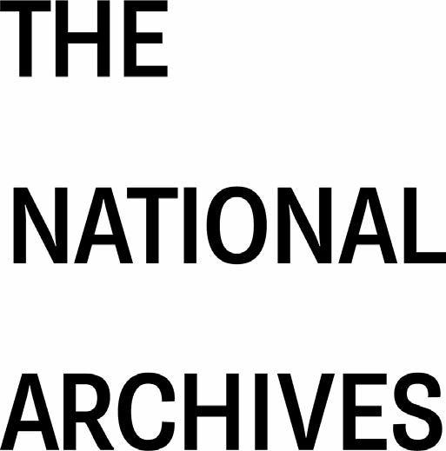

Links between access and re-use
 | Explaining the interface between access to and re-use of public sector information, and providing simple wording about re-use for responses to access requests
© Crown copyright 2026

You may use and re-use the information in this document (not including logos) free of charge in any format or medium, under the terms of the Open Government Licence v3.0
 | You can email enquiries to psi@nationalarchives.gsi.gov.uk
Version 2.1 |  |  | October 2026

Contents

Links between access and re-use 1
The distinction between access and re-use 3
Permission to re-use information 3
Access and re-use requests 4
Access and re-use complaints and appeals 4
Scope of re-use 5
Copyright notices 5
Contact details 7

The distinction between access and re-use

Access to most public sector information is provided for by the Freedom of Information Acts and by the Environmental Information Regulations.

Access to personal information is provided under the Data Protection legislation, although the information may belong to the public sector body holding it, rather than the subject.

Providing information under access legislation does not mean that the recipient has an automatic right to re-use it (for example to publish it or adapt it in some way). If information is supplied in response to an access request, and it is protected by copyright or other restrictions, then permission to re-use it will be required.

The Re-use of Public Sector Information Regulations 2015 (the 2015 Regulations) provide a framework for obtaining permission to re-use, but not to access, information. The 2015 Regulations do not apply unless the information has already been provided to a requester, or the information is otherwise accessible to the applicant (for example if it is already published online).

Permission to re-use information

A public sector body can usually provide information received from another source in response to an access request, but it may not be able to give permission to re-use that information. Permission must be given by the copyright owner of the information, who may not necessarily be the body holding the information (e.g., in a register or an archive).

The 2015 Regulations do not apply to information where copyright is owned by a third party. If you want to re-use information held by a public sector body but where the copyright is owned by someone else, you must request permission from the copyright owner. If you re-use without permission, you will infringe the owner’s copyright, unless you are able to re-use it under one of the copyright exceptions.

Most material created by central government departments enjoys Crown copyright status. Government policy is that it is usually licensed under the Open Government Licence (the OGL) and so is automatically available for re-use where it is accessible. The National Archives is responsible for Crown copyright and our website gives details on dealing with Crown copyright material.

Non-Crown public sector bodies may use other types of licences, for example the Non-commercial Government Licence, and licensing information should be available on the body’s website.

Databases provided by public sector bodies in response to an access request, or published and accessible online, may engage database rights. Most databases created by central government will enjoy Crown database right status, and like Crown copyright material should be licensed under the OGL as default, allowing re-use. In the case of the release of a database containing third party database rights, permission must be sought from the rights holder for re-use, unless exceptions to database rights apply.

Resources from The National Archives
- About PSI (public sector information)
- Re-using Public Sector Information
- Licensing for re-use
- UK Government Licensing Framework

Resources for organisations from the Information Commission
- Guide to Freedom of Information
- Guide to the Environmental Information Regulations

Access and re-use requests

Access requests should be made according to the requirements of the relevant access legislation. The public sector body may assume that re-use of the information is not intended unless the applicant specifies otherwise.

Re-use requests for information that has not already been provided or is not otherwise already accessible should be handled as access requests. The public sector body must meet the requirements of access legislation, including response times.

Only when the information is provided will it become eligible for re-use. At that point the re-use element of the request will become a valid re-use request.

Re-use requests for information that has already been provided or is otherwise already accessible should be made according to the 2015 Regulations.

Access and re-use complaints and appeals

Complaints about access or about the handling of access requests should be made first to the public sector body so it can try to resolve the complaint itself. If the complaint cannot be resolved, the requester can take it to the Information Commission (IC). The IC will issue a decision notice if it believes the public sector body did not fulfil its responsibilities under access legislation in the correct manner.

Complaints about re-use under the 2015 Regulations should be made first to the public sector body so it can try to resolve the complaint itself. If the complaint cannot be resolved by the public sector body, the re-user may take their complaint to the IC. The IC will notify the Scottish Information Commissioner (SIC) if the complaint relates to a Scottish public sector body and the IC and the SIC may share relevant information. The IC will make a binding decision or a recommendation (based on the nature of the complaint).

Details of rights of further appeal will be given by the Information Commission when it issues its decisions or recommendations.

Resources
- Information Commission
- The National Archives – Complaints about re-use

Scope of re-use

Information held by most public sector bodies is within the scope of the 2015 Regulations, including the cultural sector (libraries, including university libraries, museums and archives).

However, not all public sector bodies that are subject to access legislation are required to permit re-use of their information. In particular, the cultural sector may decline requests for re-use (although they may be challenged).

Copyright notices

When supplying information in response to an access request, public sector bodies should make it clear if there any limitations on re-use. Crown bodies may only make information available for re-use on Open Government Licence (OGL) terms, unless they have a delegation of authority from the Keeper of Public Records. Non-Crown bodies may make use of the wording of the sample copyright notices below, or may also use the OGL.

Sample wording – open licence
Using information under this licence

Use of copyright and database right material expressly made available under this licence (the 'Information') indicates your acceptance of the terms and conditions below.

The Licensor grants you a worldwide, royalty-free, perpetual, non-exclusive licence to use the Information subject to the conditions below.

This licence does not affect your freedom under fair dealing or fair use or any other copyright or database right exceptions and limitations.

You are free to:
- copy, publish, distribute and transmit the Information
- adapt the Information
- exploit the Information commercially and non-commercially for example, by combining it with other Information, or by including it in your own product or application

Sample wording – giving limited permission to re-use
Most of the information that we provide in response to Freedom of Information Act 2000 [or other access legislation as appropriate] requests will be subject to copyright protection. In most cases the copyright will be owned by [insert name of public sector organisation. The copyright in other information may be owned by another person or organisation, and this will be indicated on the information itself.

You are free to use any information supplied for your own non-commercial research or private study purposes. The information may also be used for any other purpose allowed by a limitation or exception in copyright law, such as news reporting. However, any other type of re-use, for example by publishing the information in analogue or digital form, including on the internet, will require the permission of the copyright owner.

For information where the copyright is owned by the [insert name of public sector organisation], details of the conditions on re-use can be found on our website at [insert link]. For information where the copyright is owned by another person or organisation, you must apply to the copyright owner to obtain their permission.

Contact details

Information Commission
www.ico.org.uk/global/contact-us/

Office of the Scottish Information Commissioner
Email: enquiries@itspublicknowledge.info
www.itspublicknowledge.info

The National Archives
Email: psi@nationalarchives.gov.uk
www.nationalarchives.gov.uk/

Freedom of Information Act 2000 and Freedom of Information (Scotland) 2002; Environmental Information Regulations 2004 and Environmental Information (Scotland) Regulations 2004
Exclusions to the 2015 Regulations are detailed in Regulation 5

