 | 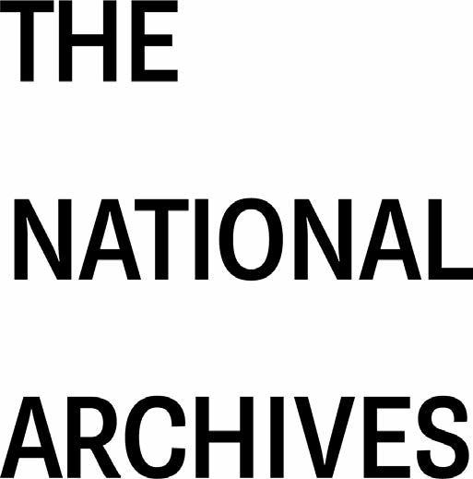

Scope of the Re-use of Public Sector Information Regulations 2015
© Crown copyright 2025

You may use and re-use the information in this document (not including logos) free of charge in any format or medium, under the terms of the Open Government Licence v3.0
 | You can email enquiries to psi@nationalarchives.gsi.gov.uk
Version 2.1 |  |  | October 2026

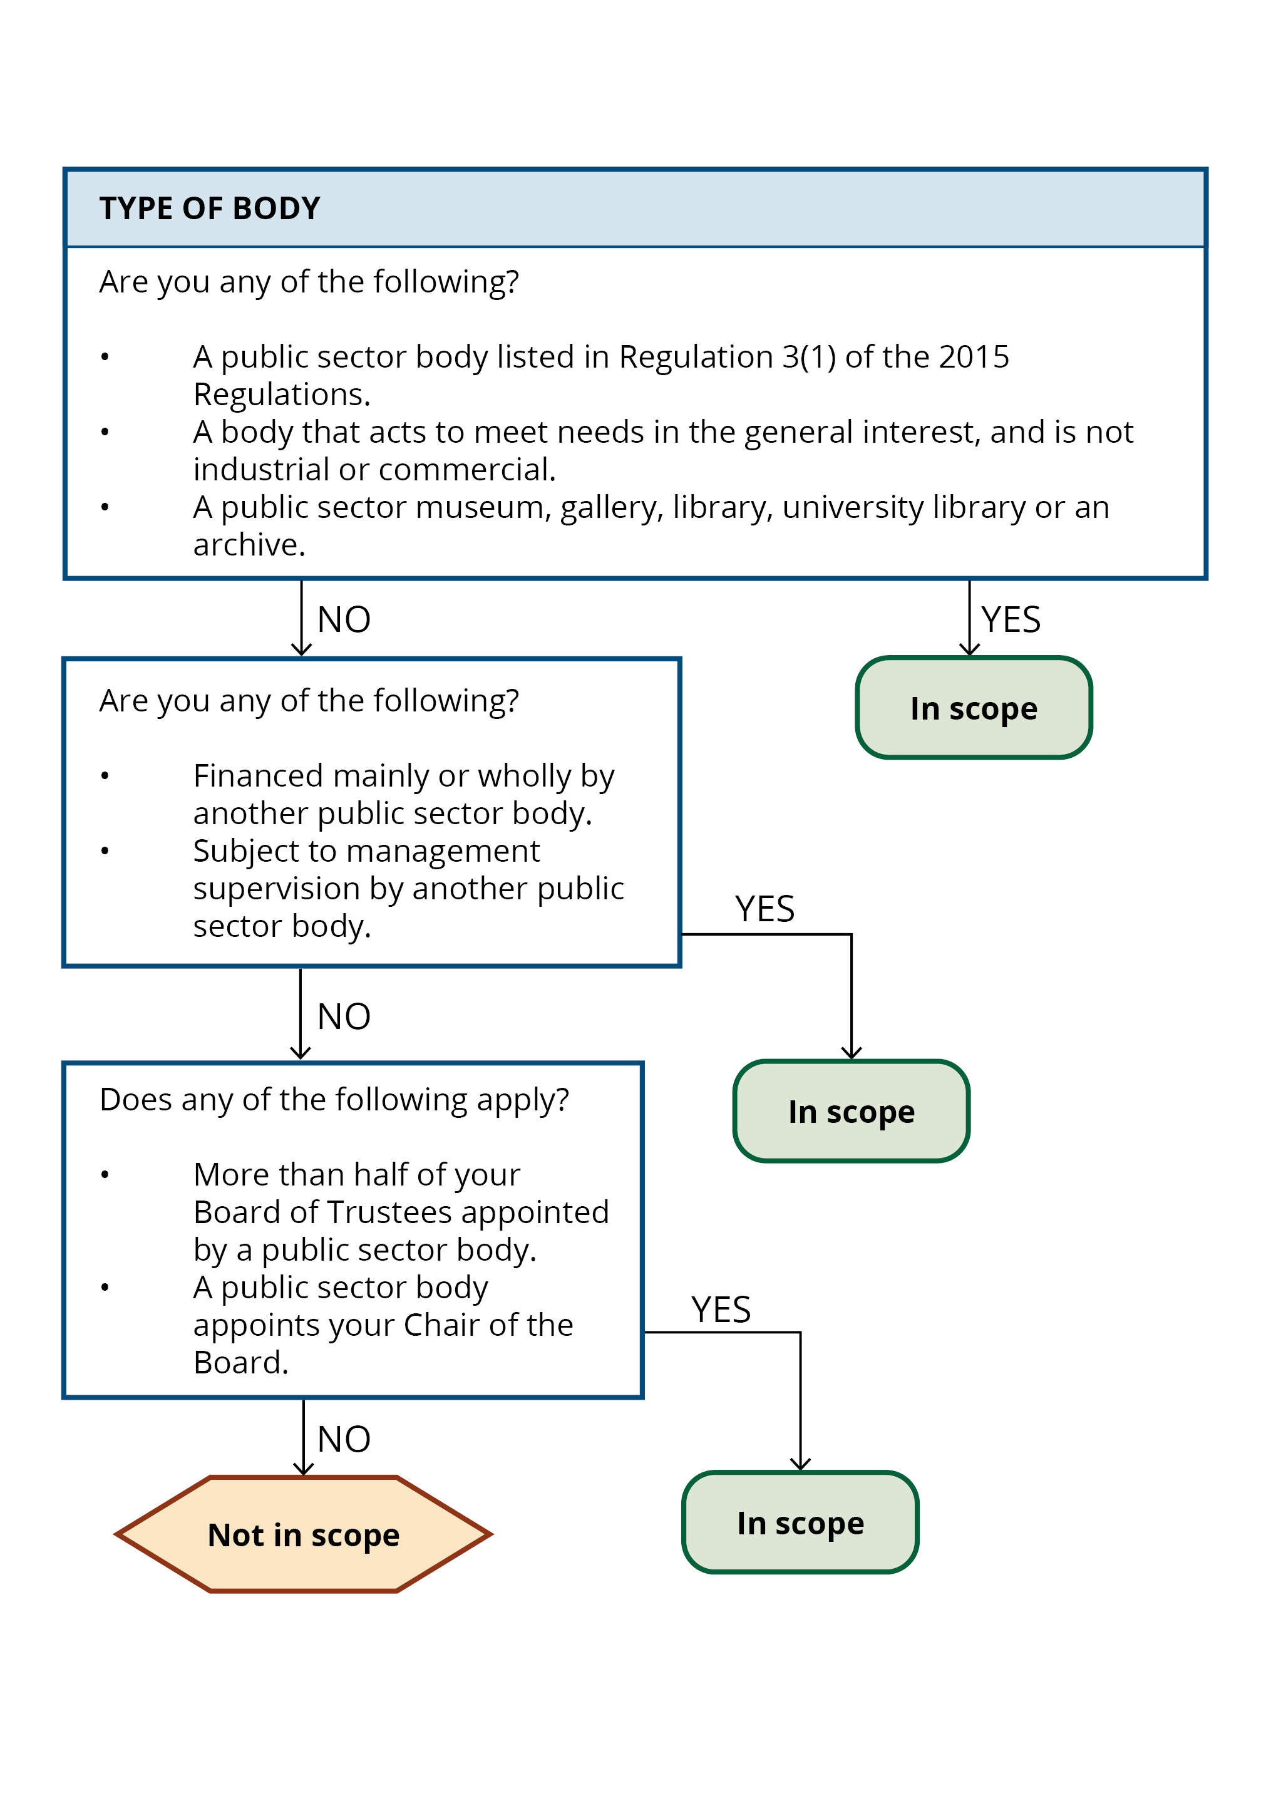

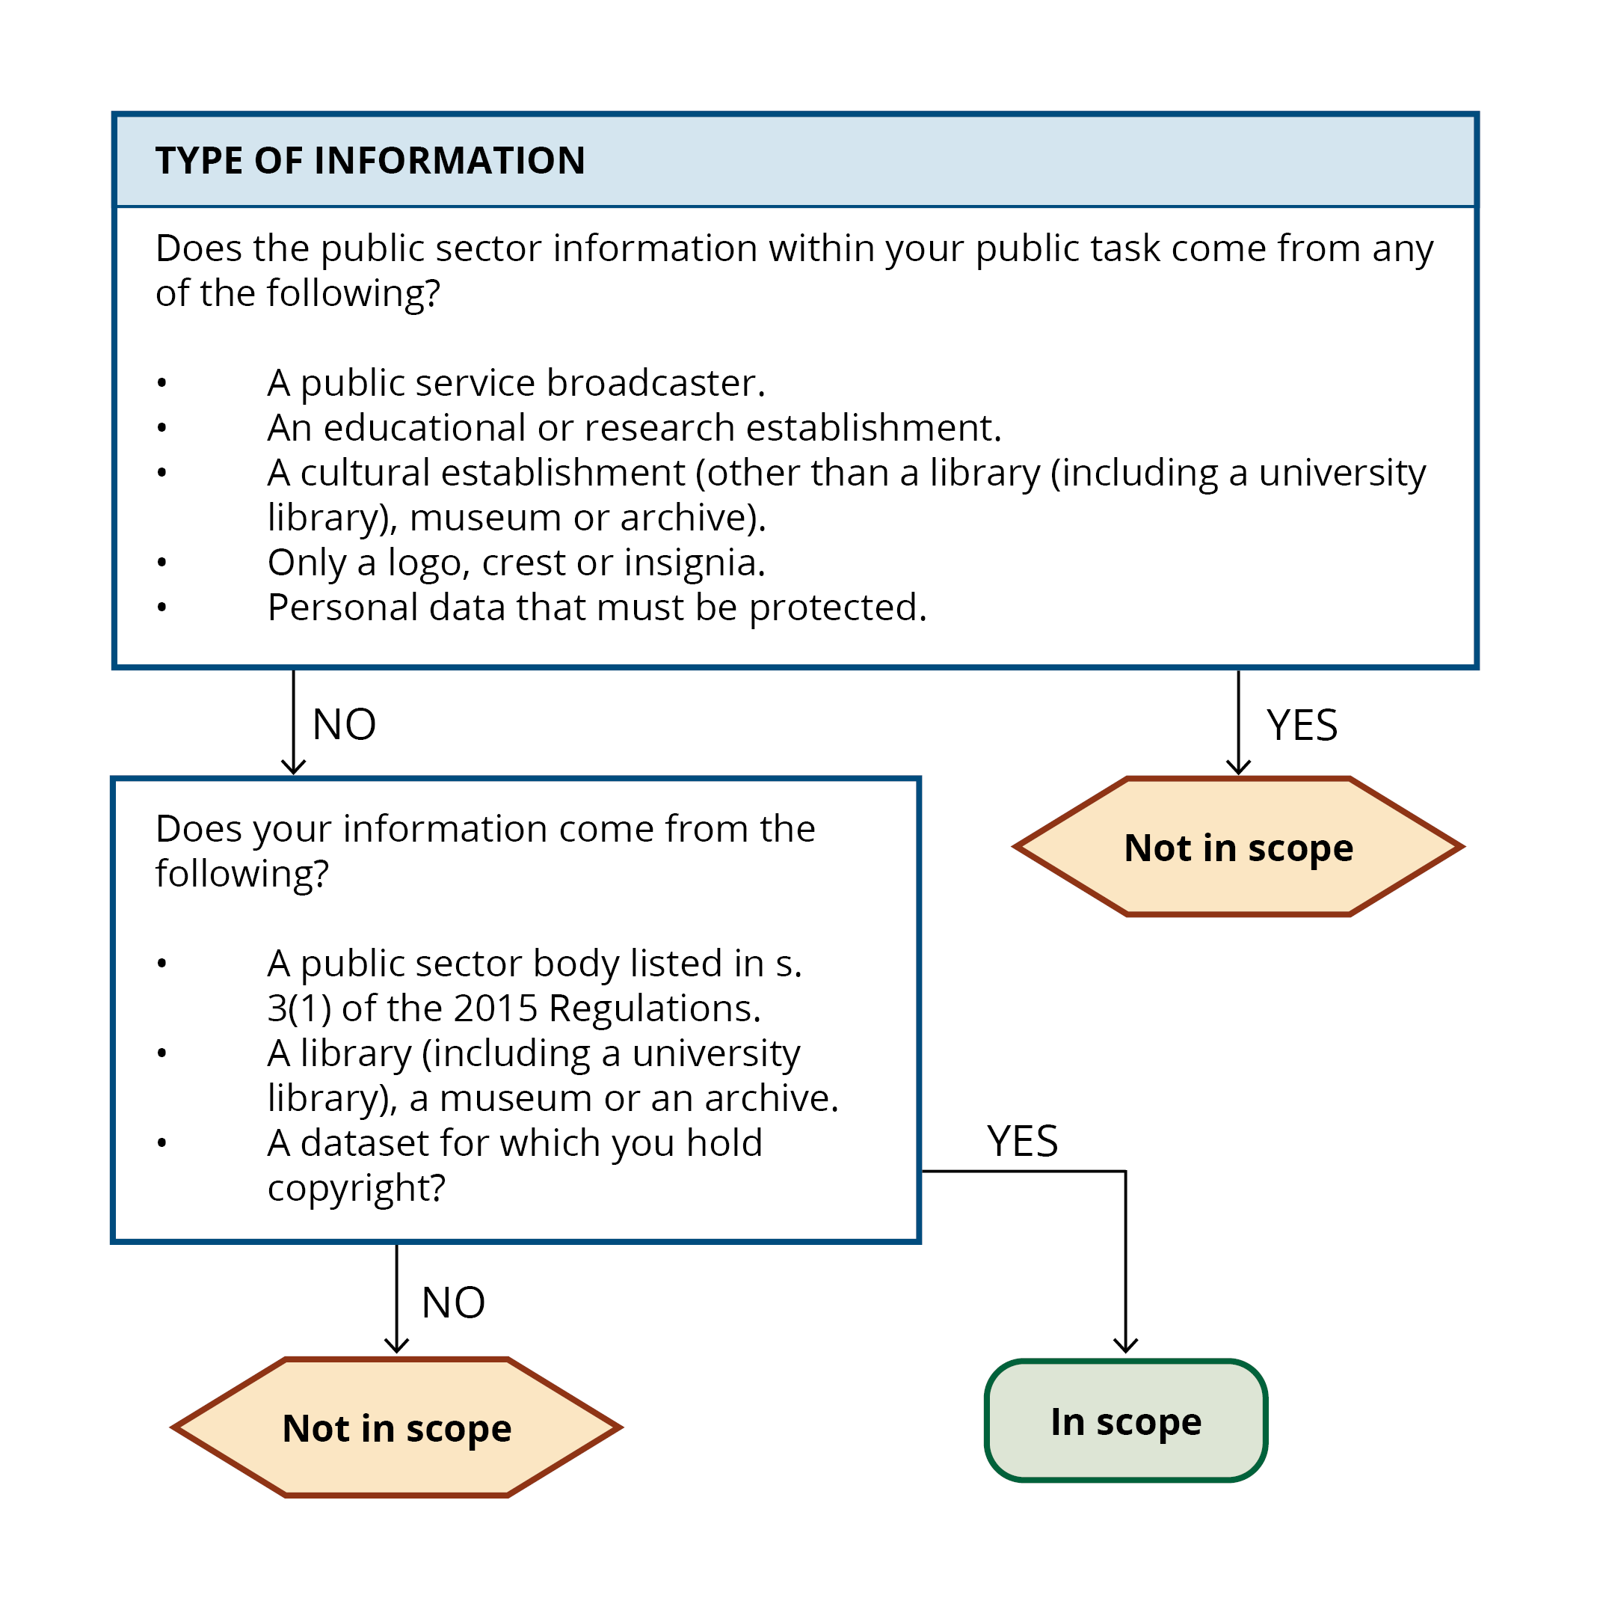

Step 1: Type of body

Questions to ask yourself:
Are you a public sector body listed in Regulation 3(1) of the 2015 Regulations?
Are you a body that acts to meet needs in the general interest, and is not industrial or commercial?
Are you a public sector museum, gallery, library, university library or an archive?

If yes to any of the above, then you are in scope.

If no to any of the above, ask yourself:
Are you financed mainly or wholly by another public sector body?
Are you subject to management supervision by another public sector body?

If yes to either, you are in scope.

If no to any of the above, ask yourself:
Is more than half of your Board of Trustees appointed by a public sector body?
Does a public sector body appoint your Chair of the Board?

If yes to either, then you are in scope.

If no to all, your body is unlikely to be in scope based on the type of body that you are. However, consider the type of information you are using and move to Step 2 to assess if that is in scope.

Step 2: Type of information

Questions to ask yourself:
Are you:
A public service broadcaster?
An educational or research establishment?
A cultural establishment (other than a library (including a university library), museum or archive?

If yes to any of the above, then while you are a public sector body, the information that you hold is not in scope.

Does the public sector information within your public task consist of:
Only a logo, crest or insignia?
Personal data that must be protected?

If yes to any of the above, then it is not in scope.

If no, ask yourself:
Does your information come from:
A public sector body listed in s.3 (1) of the 2015 Regulations?
A library (including a university library), a museum or an archive?
A dataset for which you hold copyright?

If yes, it is in scope.
If no, it is not in scope.

