

UK Archive Sector Survey 2025
 | England Report
Commissioned by The National Archives. Created by Kazky Ltd. |  |  |  | July 2025

Version

Date | Description
1 July 2025 | First draft created by Kazky for The National Archives.

Contents
1. Introduction 4
1.1 Context 4
1.2 Response rate 5
2. Results 9
2.1 Finance 9
2.2 Workforce and volunteering 18
2.3 Collections management 22
2.4 Access and engagement 31
3. Comparison with 2024 survey 52

1. Introduction

1.1 Context

The Archive Sector Leadership department (ASL) at The National Archives is responsible for the leadership of the archive sector in England. In 2025, they expanded their annual survey of archive services to the whole of the United Kingdom of Great Britain and Northern Ireland (UK) in partnership with the Archives and Records Council Wales, National Records of Scotland, Public Record Office of Northern Ireland, Scottish Council on Archives and the Welsh Government.

This replaced three surveys which were carried out in 2024:

- The Local Authority Benchmarking Exercise (England and Wales) – carried out by The National Archives for 2021/22 (collected November 2022-February 2023) and 2022/23 (collected January-March 2024). This replaced the CIPFA Archive Services Statistics (England and Wales), which covered 1988-2020/21.
- Archives sector survey for England (non-local authority services) – collected January to March 2024.
- Review of Archive Services in Wales – undertaken by the Welsh Government and included a survey of archive services in Wales covering 2022/23 – collected in February to March 2024.

The purpose of the survey was to:

- Gather evidence to help demonstrate the social and economic importance of archives to funders and stakeholders – locally, regionally, and nationally.
- Provide archive services with data to enable them to benchmark their performance.

This report outlines the results for England. For more details on the methodology for the data collection and data analysis see the UK report and the accompanying Technical Note. There are also separate regional reports for England.

1.2 Response rate

268 responses to the survey were received from England. Figures 1-3 below summarise the responses by Archive Service Accreditation status, archive type and region.

Figure 1 – Number of responses by whether the service holds Archive Service Accreditation (Q7)
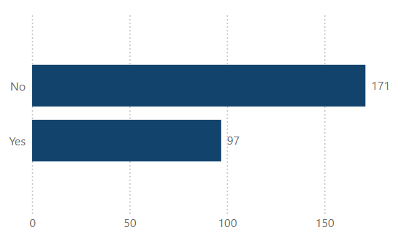
Table of data

 | Number | Percentage
No | 171 | 64%
Yes | 97 | 36%
TOTAL | 268 | 100%

Figure 2 – Number of responses by category of service
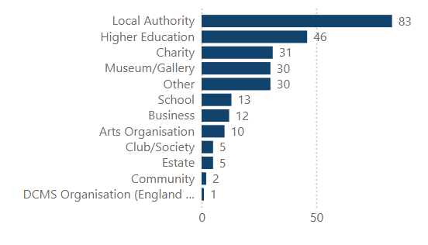

Table of data

 | Number | Percentage
Local authority | 83 | 31%
Higher Education | 46 | 17%
Charity | 31 | 12%
Museum/Gallery | 30 | 11%
Other | 30 | 11%
School | 13 | 5%
Business | 12 | 4%
Arts Organisation | 10 | 4%
Club/Society | 5 | 2%
Estate | 5 | 2%
Community | 2 | <1%
DCMS Organisation (England only) | 1 | <1%
TOTAL | 268 | 100%

Figure 3 – Number of responses in England by region
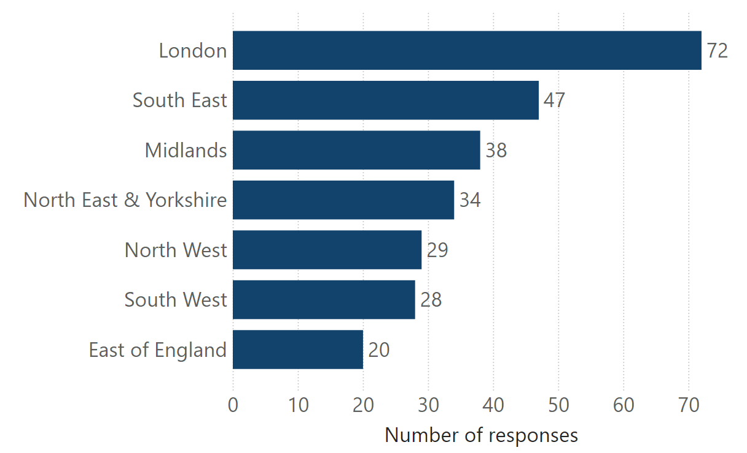
Table of data

 | Number | Percentage
London | 72 | 27%
South East | 47 | 18%
Midlands | 38 | 14%
North East & Yorkshire | 34 | 13%
North West | 29 | 11%
South West | 28 | 10%
East of England | 20 | 7%
TOTAL | 268 | 100%

2. Results

All results exclude missing values unless otherwise stated.

2.1 Finance

Figure 4 – What was your annual budget in the last financial year? (Q8)
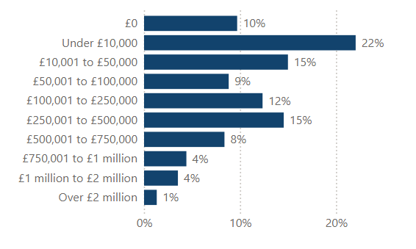

Table of data

 | Number | Percentage
£0 | 22 | 10%
Under £10,000 | 50 | 22%
£10,001 to £50,000 | 34 | 15%
£50,001 to £100,000 | 20 | 9%
£100,001 to £250,000 | 28 | 12%
£250,001 to £500,000 | 33 | 15%
£500,001 to £750,000 | 19 | 8%
£750,000 to £1 million | 10 | 4%
£1 million to £2 million | 8 | 4%
Over £2 million | 3 | 1%
TOTAL | 227 | 100%

Missing values=41 (37 “don’t know” and 4 missing)

Figure 5 – In real terms (adjusting for inflation) has your annual budget changed in the last financial year? (Q9)
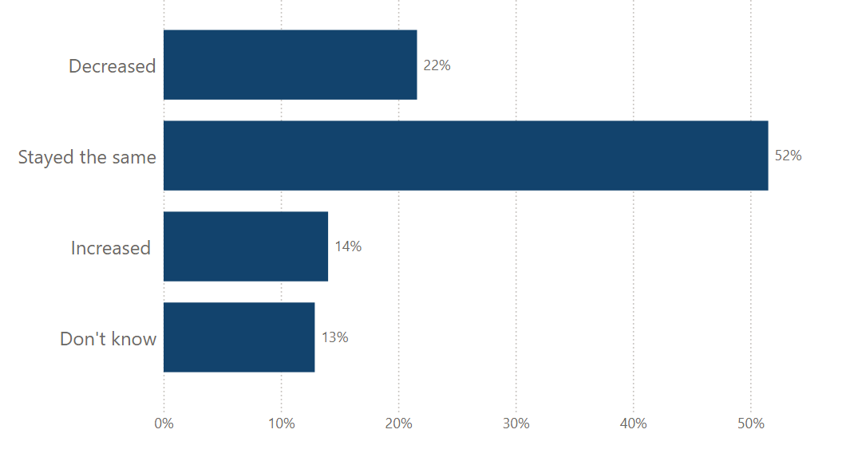
Table of data

 | Number | Percentage
Decreased | 57 | 22%
Stayed the same | 136 | 52%
Increased | 37 | 14%
Don’t know | 34 | 13%
TOTAL | 264 | 100%

Missing values=4

Table 1 – Sources of project funding (revenue) in the last financial year (Q10)

 | Number - Yes | Percentage - Yes
Not applicable | 73 | 27%
Arts Council England | 18 | 7%
Government | 18 | 7%
Local Authority | 76 | 28%
Heritage Fund | 25 | 9%
The National Archives | 21 | 8%
Local Community Trust | 15 | 6%
Other | 95 | 35%

Figure 6 – How much money did your archive receive, in revenue grant income, in the last financial year (Q11)
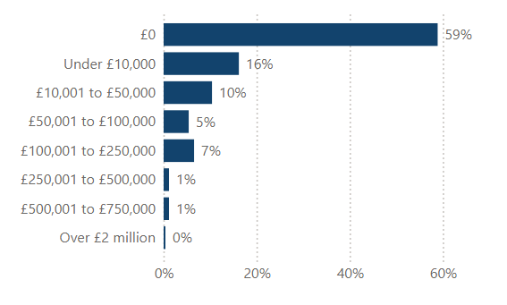
Table of data

 | Number | Percentage
£0 | 153 | 59%
Under £10,000 | 42 | 16%
£10,001 to £50,000 | 27 | 10%
£50,001 to £100,000 | 14 | 5%
£100,001 to £250,000 | 17 | 7%
£250,001 to £500,000 | 3 | 1%
£500,001 to £750,000 | 3 | 1%
£750,000 to £1 million | 0 | 0%
£1 million to £2 million | 0 | 0%
Over £2 million | 1 | <1%
TOTAL | 260 | 100%

Missing values=8

Figure 7 – How much money did your archive receive in capital grant in the last financial year? (Q12)
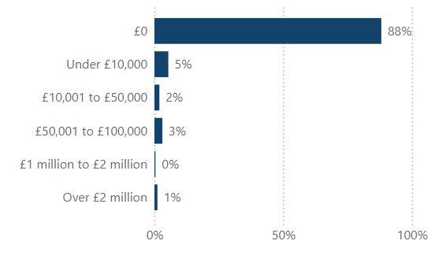
Table of data

 | Number | Percentage
£0 | 229 | 88%
Under £10,000 | 14 | 5%
£10,001 to £50,000 | 5 | 2%
£50,001 to £100,000 | 8 | 3%
£100,001 to £250,000 | 0 | 0%
£250,001 to £500,000 | 0 | 0%
£500,001 to £750,000 | 0 | 0%
£750,000 to £1 million | 0 | 0%
£1 million to £2 million | 1 | <1%
Over £2 million | 3 | 1%
TOTAL | 260 | 100%

Missing values=8

Figure 8 – What was the value of your earned income in the financial year? (Q13)
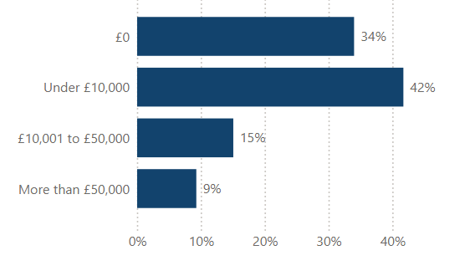
Table of data

 | Number | Percentage
£0 | 88 | 34%
Under £10,000 | 108 | 42%
£10,001 to £50,000 | 39 | 15%
More than £50,000 | 24 | 9%
TOTAL | 259 | 100%

Missing values=9

2.2 Workforce and volunteering

Table 2 – Number of staff (Q14-Q20)

 | Average per service (FTE) | Median per service (FTE) | Number of missing values
All paid staff | 7.20 | 2 | 10
Qualified archivist | 1.96 | 1 | 10
Non-qualified archivists/assistants | 2.27 | 1 | 13
Qualified conservation staff | 0.36 | 0 | 22
Non-qualified conservation staff | 0.18 | 0 | 19
Education and learning staff | 0.38 | 0 | 23
Records management staff | 0.38 | 0 | 26

Figure 9 – What is the total full-time equivalent count of paid staff employed at your archive? (Q14 Categorical)
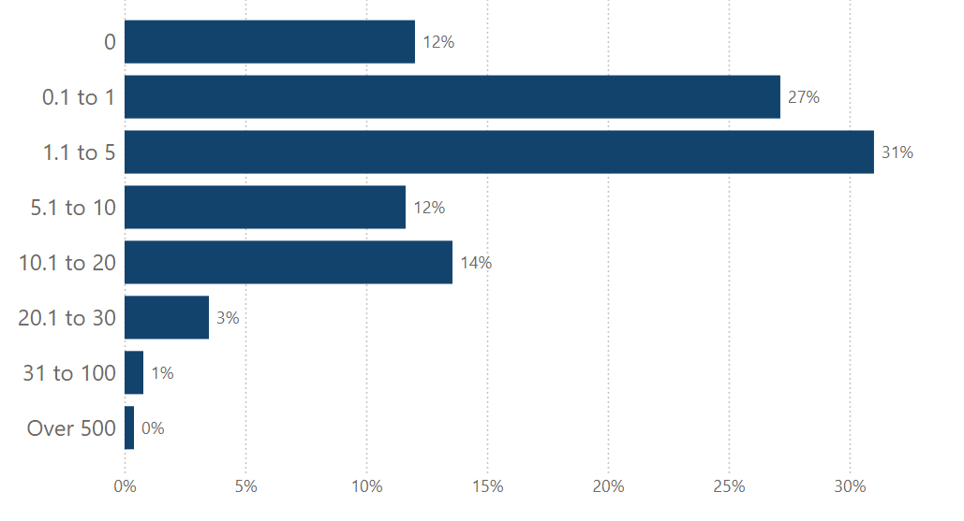

Table of data

 | Number | Percentage
0 | 31 | 12%
0.1 to 1 | 70 | 27%
1.1 to 5 | 80 | 31%
5.1 to 10 | 30 | 12%
10.1 to 20 | 35 | 14%
20.1 to 30 | 9 | 3%
31 to 100 | 2 | <1%
101 to 499 | 0 | 0%
Over 500 | 1 | <1%
TOTAL | 258 | 100%

Missing values=10

Table 3 – Volunteer numbers and hours (Q21-Q23)

 | Average per service | Median per service | Number of missing values
Number of volunteers | 15.97 | 4 | 15
Volunteer hours (onsite) | 1,291 | 250 | 40
Volunteer hours (online) | 146 | 0 | 57
Volunteer hours (all) | 1,420 | 350 | 39

Note – the analysis includes those services that do not host volunteers and entered 0. 79% of services hosted volunteers.

2.3 Collections management

Table 4 – Holdings and storage (Q24, Q25, Q28, Q32)

 | Average per service | Median per service | Number of missing values
Analogue archive holdings (cubic metres) | 559 | 177 | 95
Percentage stored to BS4971 | 67.9% | 90% | 43
Onsite accrual space (years) | 9.13 | 5 | 105
Born-digital archival holdings (GB) | 2,903 | 186 | 120

Figure 10 – Do you use commercial storage for archival holdings? (Q30)
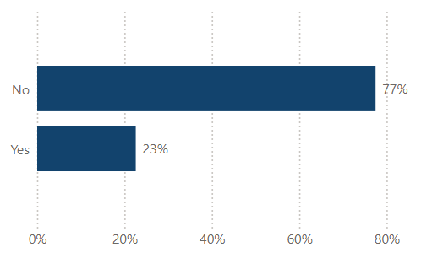
Table of data

 | Number | Percentage
No | 206 | 77%
Yes | 60 | 23%
TOTAL | 266 | 100%

Missing values=2

Table 5 – What is the main collection management system (CMS) you currently use? (Q30)

 | Number - Yes | Percentage – Yes
None | 47 | 18%
AdLib | 10 | 4%
ArchivesSpace | 8 | 3%
AtoM | 14 | 5%
Axiell Collections | 16 | 6%
Axiell Emu | 5 | 2%
Bespoke/in-house | 15 | 6%
CALM | 89 | 33%
Collections Index (System Simulation) | 6 | 2%
CollectionsBase (Orangeleaf Systems) | 7 | 3%
ContentDM (OCLC) | 2 | <1%
Dryad (Max Communications) | 1 | <1%
eHive (Vernon Systems) | 1 | <1%
Epexio (Metadatis) | 23 | 9%
Koha | 1 | <1%
M2A (Minisis) | 1 | <1%
Mimsy | 6 | 2%
Modes | 8 | 3%
Qi | 2 | <1%
SDS Archive Manager | 2 | <1%
Soutron Archive | 5 | 2%
Spydus (Civica) | 5 | 2%
TMS Media Studio (Gallery Systems) | 1 | <1%
VernonCMS | 2 | <1%
Other | 36 | 13%

Table 6 – What is the main digital preservation management system (DPS) you currently use? (Q34)

 | Number - Yes | Percentage – Yes
None | 132 | 49%
Archivematica | 7 | 3%
Arkivum Perpetua | 2 | <1%
EPrints | 1 | <1%
In-house workflows connecting tools into a digital preservation architecture | 27 | 10%
Libsafe (Libnova) | 2 | <1%
Preservica | 61 | 23%
Other | 28 | 10%

Table 7 – Does your service use any of the following tools or standards to guide your approach to digital preservation? (Q33)

 | Number - Yes | Percentage – Yes
None in use | 120 | 45%
Core Trust Seal | 4 | 1%
DiAGRAM | 5 | 2%
Digital Preservation Coalition Rapid Assessment Model | 74 | 28%
ISO 16363 | 13 | 5%
NDSA Levels of Digital Preservation | 62 | 23%
OAIS Reference Model | 66 | 25%
Other | 13 | 5%

Figure 11 – What kind of conservation do you have access to (Q26)?
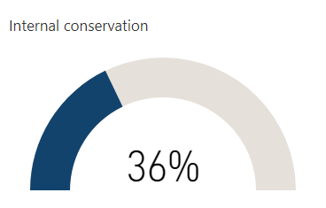
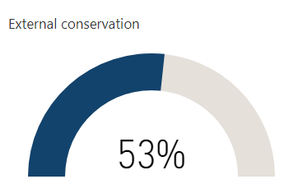
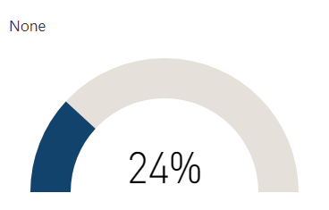

Table of data

 | Number - Yes | Percentage – Yes
Internal | 95 | 36%
External | 142 | 53%
None | 63 | 24%

Missing values=2

Table 8 – Catalogues: percentage catalogued and online

 | Average per service | Median per service | Number of missing values
Percentage of archive collection fully catalogued | 53% | 55% | 33
Percentage of archive collection with full catalogue online | 40% | 40% | 37
Percentage of archive collection completely unlisted | 22% | 13% | 47

2.4 Access and engagement

Figure 12 – Is your archive open to the general public? (in-person) (Q38)
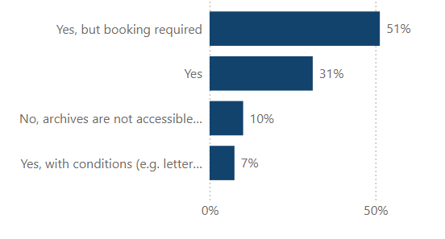
Table of data

 | Number | Percentage
Yes but booking required | 137 | 51%
Yes | 83 | 31%
No, archives are not accessible to the public | 27 | 10%
Yes, with conditions (e.g. letter of introduction) | 20 | 7%
TOTAL | 267 | 100%

Missing values=1

Figure 13 – Does your archive service provide free public Wi-Fi? (Q46)
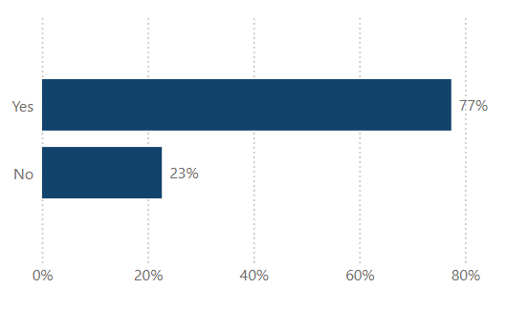
Table of data

 | Number | Percentage
Yes | 205 | 77%
No | 60 | 23%
TOTAL | 265 | 100%

Missing values=3

Figure 14 – Does your archive service have access to a library collection that supports research into your archival holdings? (Q27)
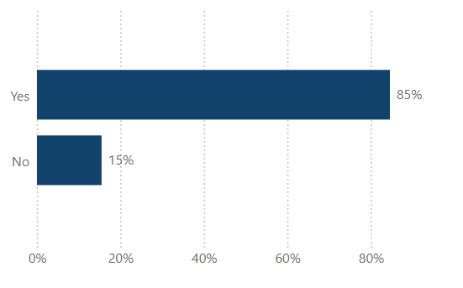
Table of data

 | Number | Percentage
Yes | 224 | 85%
Yes | 41 | 15%
TOTAL | 265 | 100%

Missing values=3

Figure 15 – Does your archive service collect demographic data about your audiences? (Q51)
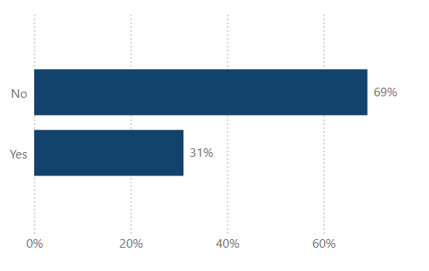
Table of data

 | Number | Percentage
No | 183 | 69%
Yes | 82 | 31%
TOTAL | 265 | 100%

Missing values=3

Table 9 – In-person opening hours and reader spaces (Q40-Q42)

 | Average per service | Median per service | Number of missing values
Hours open per week | 25.18 | 24 | 38
Weeks open per year | 47.20 | 50 | 31
Hours open per year | 1,342 | 1,170 | 40
Number of onsite readers service can accommodate at one time | 12.68 | 6 | 16

Note – only those services that are open to the public included in the analysis.

Table 10 – Visits, enquiries, and productions in the past year (Q39, Q43-Q45)

 | Average per service | Median per service | Number of missing values
In-person visits (those services open to the public in-person only) | 5,813 | 306 | 34
Enquiries | 1,496 | 400 | 47
Analogue items produced | 5,173 | 2,143 | 119
Born-digital items accessed (GB) | 1.68 | 0 | 190
Born-digital items accessed (number) | 33,348 | 0 | 149

Figure 16 - How many onsite and offsite learning and outreach events combined did your archive service hold in the last year? (Q47)

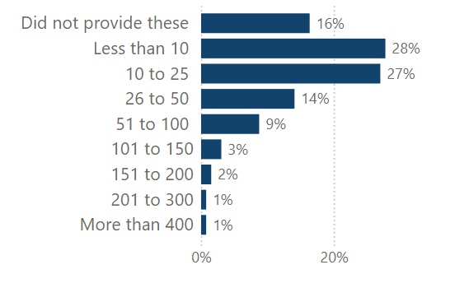

Table of data

 | Number | Percentage
Did not provide these | 43 | 16%
Less than 10 | 73 | 28%
10 to 25 | 71 | 27%
26 to 50 | 37 | 14%
51 to 100 | 23 | 9%
101 to 150 | 8 | 3%
151 to 200 | 4 | 2%
201 to 300 | 2 | <1%
301 to 400 | 2 | <1%
More than 400 | 0 | 0%
TOTAL | 260 | 100%

Missing values=5

Figure 17 - How many participants did your archive engage in learning and outreach sessions online? (Q48)
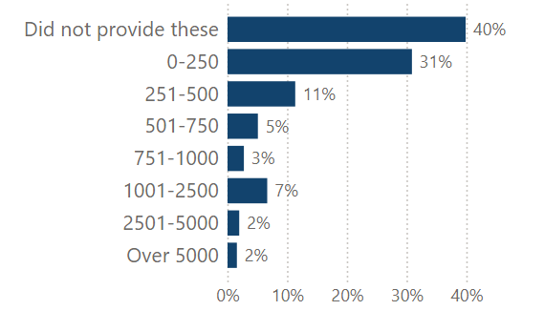
Table of data

 | Number | Percentage
Did not provide these | 102 | 40%
0 to 250 | 79 | 31%
251 to 500 | 29 | 11%
501 to 750 | 13 | 5%
751 to 1000 | 7 | 3%
1001 to 2500 | 17 | 7%
2501 to 5000 | 5 | 2%
Over 5000 | 4 | 2%
TOTAL | 256 | 100%

Missing values=12

Figure 18 - How many visitors attended your exhibitions on-site and off-site in the last year? (Q49)
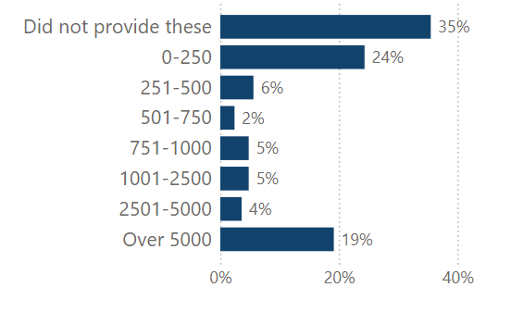
Table of data

 | Number | Percentage
Did not provide these | 89 | 35%
0-250 | 61 | 24%
251-500 | 14 | 6%
501-750 | 6 | 2%
751-1000 | 12 | 5%
1001-2500 | 12 | 5%
2501-5000 | 9 | 4%
Over 5000 | 48 | 19%
TOTAL | 251 | 100%

Missing Values=17

Figure 19 - How many visitors attended your exhibitions online in the last year? (Q50)
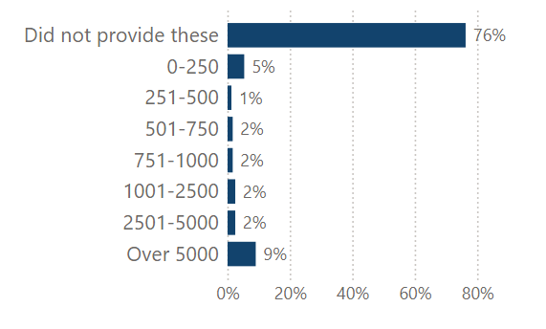

Table of data

 | Number | Percentage
Did not provide these | 186 | 76%
0-250 | 13 | 5%
251-500 | 3 | 1%
501-750 | 4 | 2%
751-1000 | 4 | 2%
1001-2500 | 6 | 2%
2501-5000 | 6 | 2%
Over 5000 | 22 | 9%
TOTAL | 244 | 100%

Missing Values=24

Table 11 – Does your archive use any of the following social media platforms (Q52)?
 | Number - Yes | Percentage - Yes
Twitter/X | 100 | 37%
Facebook | 111 | 41%
Instagram | 96 | 36%
YouTube | 54 | 20%
Threads | 6 | 2%
Blog | 47 | 18%
Pinterest | 2 | <1%
TikTok | 6 | 2%
Flickr | 16 | 6%
Bluesky | 19 | 7%
Mastodon | 0 | 0%
None in use | 21 | 8%
Don’t know | 1 | <1%
No but contribute to parent organisation' accounts | 107 | 40%

Figure 20 - Was the service able to provide how many followers/subscribers they have to their social media accounts? (Q53)
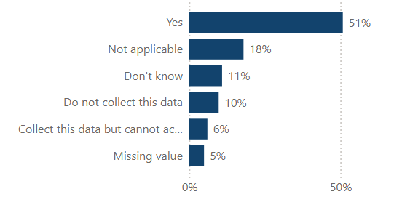
Table of data

 | Number | Percentage
Yes | 136 | 51%
Not applicable | 48 | 18%
Don’t know | 29 | 11%
Do not collect data | 26 | 10%
Collect this data but cannot access | 16 | 6%
Missing data | 13 | 5%
TOTAL | 268 | 100%

Figure 21 - How many followers/subscribers did your archive have to its social media accounts? (Q53)
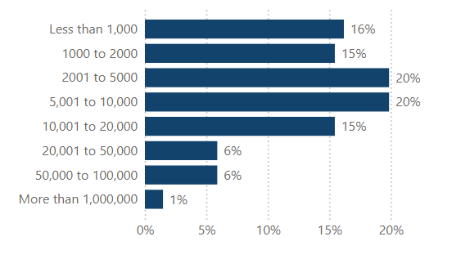

Table of data

 | Number | Percentage
Less than 1000 | 22 | 16%
1000 to 2000 | 21 | 15%
2001 to 5000 | 27 | 20%
5001 to 10,000 | 27 | 20%
10,001 to 20,000 | 21 | 15%
20,001 to 50,000 | 8 | 6%
50,000 to 100,000 | 8 | 6%
More than 1,000,000* | 2 | 1%
TOTAL | 136 | 100%

*This was included in the survey but should probably read 100,000

Missing values=132 (includes not applicable/don't know/do not collect/unable to access)

Figure 22 - Was the service able to provide the total number of unique visitors to their website? (Q54)
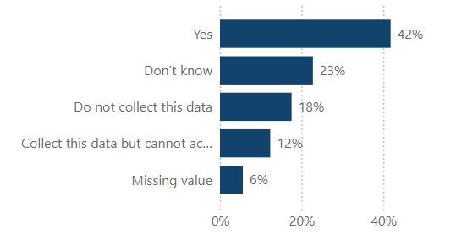
Table of data

 | Number | Percentage
Yes | 112 | 42%
Don’t know | 61 | 23%
Do not collect data | 47 | 18%
Collect this data but cannot access | 33 | 12%
Missing data | 15 | 6%
TOTAL | 268 | 100%

Figure 23 - What was the total number of unique visitors to your website? (Q54)
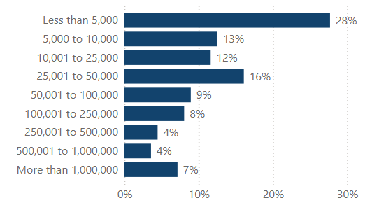
Table of data

 | Number | Percentage
Less than 5,000 | 31 | 28%
5,000 to 10,000 | 14 | 13%
10,001 to 25,000 | 13 | 12%
25,001 to 50,000 | 18 | 16%
50,001 to 100,000 | 10 | 9%
100,001 to 250,000 | 9 | 8%
250,001 to 500,000 | 5 | 4%
500,001 to 1,000,000 | 4 | 4%
More than 1,000,000 | 8 | 7%
TOTAL | 112 | 100%

Missing values=156 (includes not applicable/don't know/do not collect/unable to access)

3. Comparison with 2024 survey

We identified 145 services in England that replied to the 2025 and the 2024 surveys. Table 12 below summarises the results for these services for some variables. The analysis only includes those who answered the relevant questions in both years.

Table 12 – Comparison between 2024 and 2025 surveys for those services that participated in both surveys (England only)
 | 2024  Average | 2025  Average | Number of values included in analysis
Hours open per week* | 25.77 | 25.76 | 117
Total staff FTE | 6.79 | 6.70 | 139
Total in-person visits* | 9,386 | 9,702 | 116
Percentage of archive collection completely unlisted | 13.84 | 17.31 | 122
Analogue archive holdings (cubic metres) | 658 | 719 | 95
Digital preservation tools and standards – None in Use | 50% | 38% | 134
Digital preservation system - None | 50% | 45% | 134

*Only those services that are open to the public included in the analysis.

